Task 4

1. Retrieve the customer(s) with the highest account balance.

Query:

SELECT CONCAT(first_name,last_name) AS name, customer_id, balance

FROM customers

WHERE balance=(SELECT MAX(balance) FROM accounts;

1. Calculate the average account balance for customers who have more than one account.

Query:

SELECT AVG(balance) FROM accounts

WHERE customer_id IN

(SELECT customer_id FROM accounts

GROUP BY customer_id

HAVING COUNT(customer_id)>1);

Output:

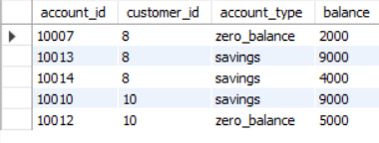

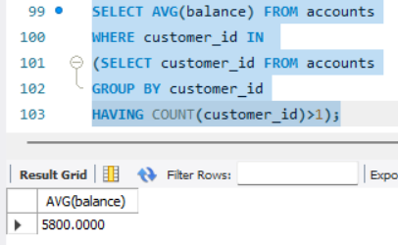

1. Retrieve accounts with transactions whose amounts exceed the average transaction amount.

Query:

SELECT account_id FROM transaction

WHERE amount > (SELECT AVG(amount)

FROM transaction);

Output:

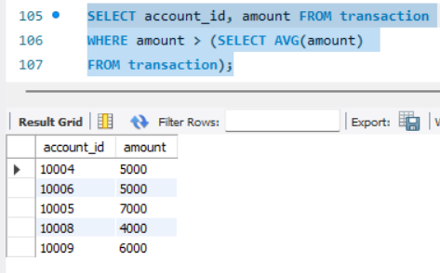

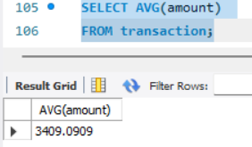

1. Identify customers who have no recorded transactions.

Query:

SELECT customer_id,CONCAT(first_name,last_name) AS name

FROM customers

WHERE customer_id = (SELECT customer_id

FROM accounts

WHERE account_id = (SELECT account_id FROM transaction

WHERE transaction_id IS NULL));

Output:

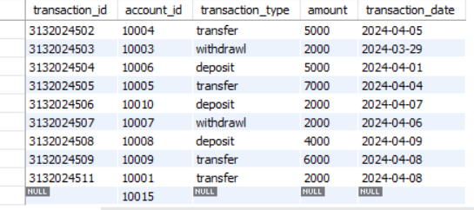

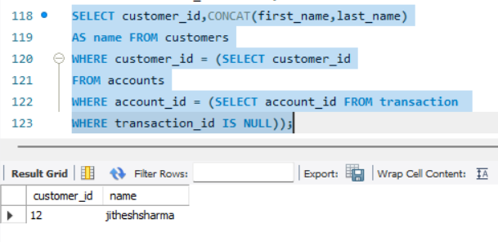

1. Calculate the total balance of accounts with no recorded transactions.

Query:

SELECT balance

FROM accounts

WHERE account_id = (SELECT account_id

FROM transaction

WHERE transaction_id IS NULL);

Output:

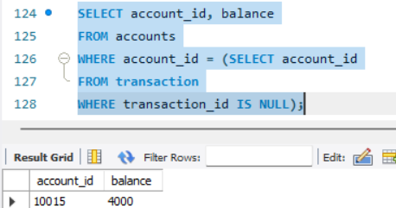

1. Retrieve transactions for accounts with the lowest balance.

Query:

SELECT transaction_id,transaction_type,amount,

transaction_date

FROM transaction

WHERE account_id = (SELECT account_id

FROM accounts

WHERE balance =(SELECT MIN(balance)

FROM accounts));

Output:

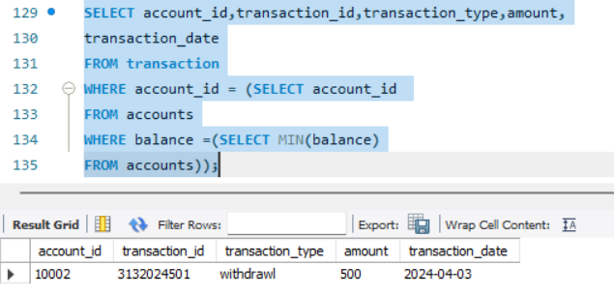

1. Identify customers who have accounts of multiple types.

Query:

SELECT customer_id,CONCAT(first_name,last_name)

AS PeopleWithMultipleTypeAccounts

FROM customers

WHERE customer_id IN (SELECT DISTINCT(customer_id)

FROM accounts

WHERE customer_id IN (SELECT customer_id

FROM accounts

GROUP BY customer_id

HAVING COUNT(customer_id)>1));

Output:

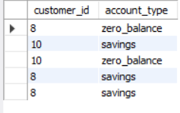

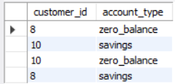

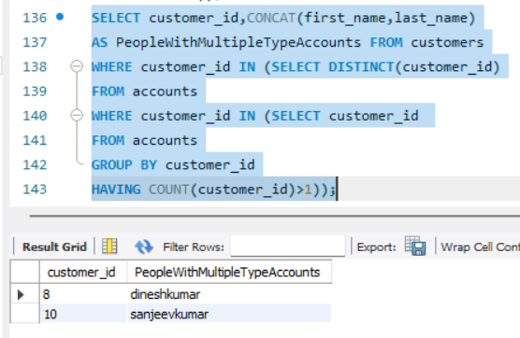

1. Calculate the percentage of each account type out of the total number of accounts.

Query:

SELECT account_type, COUNT(account_type) AS 'count',

COUNT(account_type)/(SELECT COUNT(*) FROM accounts)*100 AS Percentage

FROM accounts

GROUP BY account_type;

Output:

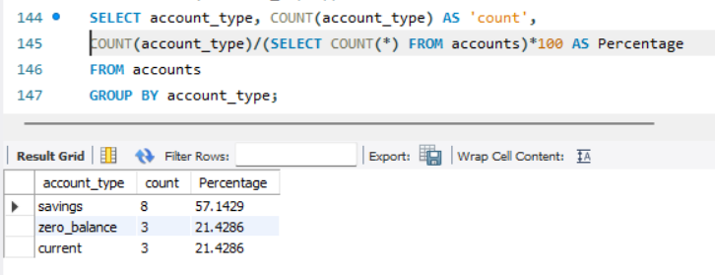

1. Retrieve all transactions for a customer with a given customer_id.

Query:

SELECT * FROM transaction

WHERE account_id = (SELECT account_id

FROM accounts

WHERE customer_id = 1);

Output:

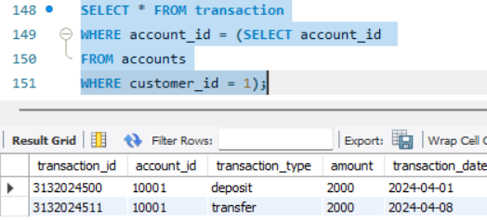

1. Calculate the total balance for each account type, including a subquery within the SELECT clause.

Query:

SELECT account_type,SUM(balance) AS total_balance,

(SELECT COUNT(*) FROM accounts A

WHERE A.account_type=accounts.account_type)

AS account_type_count

FROM accounts

GROUP BY account_type;

Output:

